1.

**package** mathOperations;

**public** **class** Armstrong {

**public** **static** **void** main(String[] args) {

**int** number=153, remainder, result =0,a;

a=number;

**while**(a !=0)

{

remainder = a % 10;

result +=Math.*pow*(remainder,3);

a /=10;

}

**if** (result==number)

System.***out***.println(number+" is a armstrong number");

**else**

System.***out***.println(number+" is not a armstrong number ");

}

}

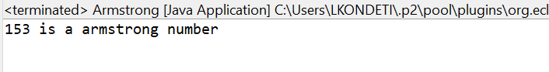

2.

**package** mathOperations;

**public** **class** ArmstrongNo {

**public** **static** **void** main(String[] args) {

**for**(**int** number=100;number<=1000;number++)

{

**int** n=number;

**int** d=0,s=0;

**while**(n>0) {

d=n%10;

s=s+(d*d*d);

n=n/10;

}

**if**(number==s)

{

System.***out***.println(number + " is a Armstrong number");

}

}

}

}

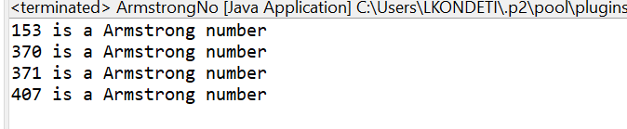

3.

**package** mathOperations;

**import** java.util.*;

**public** **class** SCInterest {

**public** **static** **void** main(String[] args) {

**double** principal, rate, time, simInterest, compInterest;

**try**(Scanner scanner = **new** Scanner (System. ***in***)){

System.***out***.println("Enter the value of Principal = ");

principal = scanner.nextDouble();

System. ***out***. println("Enter the Annual Rate of Interest = ");

rate = scanner.nextDouble();

System. ***out***. println("Enter the Time (years) = ");

time = scanner.nextDouble();

}

simInterest = (principal * rate * time)/100;

System.***out***.println("Simple Interest: "+simInterest);

compInterest = principal * Math.*pow*(1.0+rate/100.0,time) - principal;

System.***out***. println("Compound Interest: "+compInterest);

}

}

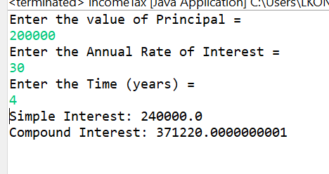

4.

**package** mathOperations;

**import** java.util.*;

**public** **class** marks {

**public** **static** **void** main(String[] args) {

Scanner sc = **new** Scanner(System.***in***);

**int** subjects;

System.***out***.println("Enter the total subjects ");

subjects=sc.nextInt();

**int** arr[] = **new** **int**[subjects];

System.***out***.println("Enter the marks secured in each subject ");

**int** index =0;

**for**(;index<arr.length;index++)

{

arr[index]=sc.nextInt();

}

**if**(arr[index]>60 == **true**) {

System.***out***.println("Passed");

}

}

}

5.

**package** mathOperations;

**import** java.util.*;

**public** **class** incomeTax {

**public** **static** **void** main(String[] args) {

**double** tax=0,it;

Scanner sc=**new** Scanner(System.***in***);

System.***out***.println("Enter income ");

it=sc.nextDouble();

**if**(it<=180000)

tax=0;

**else** **if**(it<=300000)

tax=0.1*(it-180000);

**else** **if**(it<=500000)

tax=(0.2*(it-300000))+(0.1*100000);

**else** **if**(it<=1000000)

tax=(0.3*(it-500000))+(0.2*200000)+(0.1*100000);

**else**

tax=(0.4*(it-1000000))+(0.3*500000)+(0.2*200000)+(0.1*100000);

System.***out***.println("Income tax amount is "+tax);

}

}

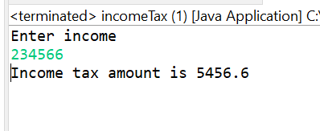

9.

**package** mathOperations;

**import** java.util.*;

**public** **class** totalAvg {

**public** **static** **void** main(String[] args) {

Scanner scan = **new** Scanner(System.***in***);

**float** marks1, marks2, marks3;

**float** sum = 0;

**float** avg = 0;

// take three numbers

System.***out***.print("Enter marks of the student A, B, C: ");

marks1 = scan.nextFloat();

marks2 = scan.nextFloat();

marks3 = scan.nextFloat();

sum = marks1 + marks2 + marks3;

System.***out***.println("sum : "+ sum);

avg = sum/3;

System.***out***.println("Average : " + avg);

}

}

